**Report of Sales Data**

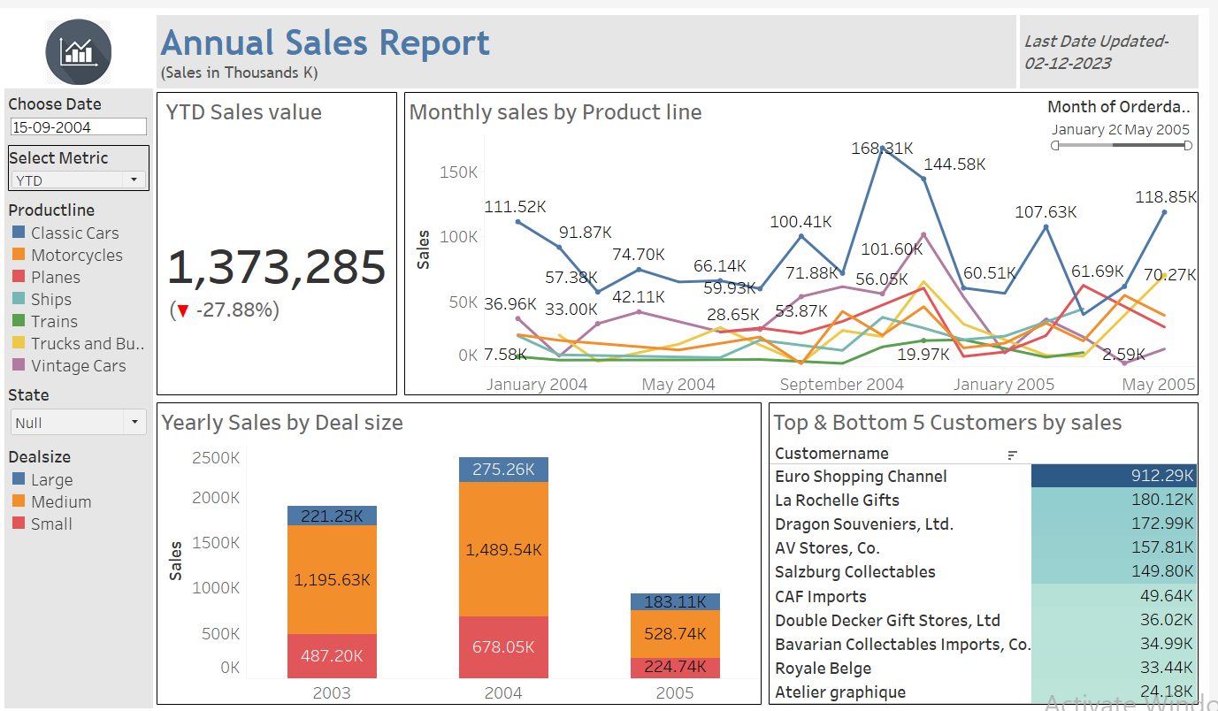

In this dashboard all the sales value has been denoted by Thousands (K)

This is basic and easy to understand report in which user can-

* Choose the Sales by Year and Month by using Metric selection also by choosing Date.
* Percentage of growth in years/month
* All the products performance by year, wherein user can select the respective product and it’ll get highlighted in the Line chart in dashboard.

*(Product lines are distinguished by colours)*

* What sales his firm did with respect to Deal size in all three years.

*(Deal sizes are distinguished by colours)*

* Users can easily know which are Top 5 customers and Bottom 5 customers who are contributing in company’s sale.
* User can also see all the charts with respect to State, which I’ve used as a filter in left panel.
* With the help of sliders ie. (Monthly/Yearly) in product line, user can slide and have the figures in the view.